15.55: a) and b) (1): The curve appears to be horizontal, and 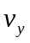 = 0. As the wave moves, the point will begin to move downward, and 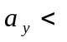0. (2): As the wave moves in the +-direction (to the right in Fig. (15.34)), the particle will move upward so > 0. The portion of the curve to the left of the point is steeper, so 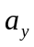 > 0. (3) The point is moving down, and will increase its speed as the wave moves; 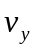 < 0, 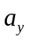< 0. (4) The curve appears to be horizontal, and = 0. As the wave moves, the point will move away from the -axis, and >0. (5) The point is moving downward, and will increase its speed as the wave moves; 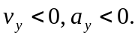(6) The particle is moving upward, but the curve that represents the wave appears to have no curvature, so 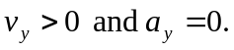 c) The accelerations, which are related to the curvatures, will not change. The transverse velocities will all change sign.

